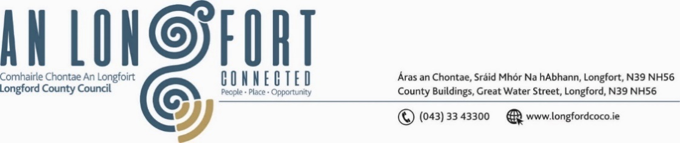

***BALLYMAHON MUNICIPAL DISTRICT***

***Please note meeting will be held in Ballymahon Library.***

**14 June 2023**

**To: Each Member of Ballymahon Municipal District.**

A Chomhairleoir,

You are requested to attend the Annual Meeting of Ballymahon Municipal District to be held in **Ballymahon Library on Thursday, 22 June 2023 at 4pm** to transact business, as set out on the Agenda hereunder.

Mise le meas,

______________

**Claire McNabola,**

**Meetings Administrator.**

**C L A R**

**1**. Election of Cathaoirleach

**2.** Election of Leas Cathaoirleach

**3**. Fix date and time of Ballymahon Municipal District meetings

